Activity 2.2: Planning and creating a leaflet
Design a leaflet to publicise the cause or event your teacher tells you about.
To make the leaflet as cheap as possible to print, your A4 document must contain two identical copies of the leaflet side by side, like this:
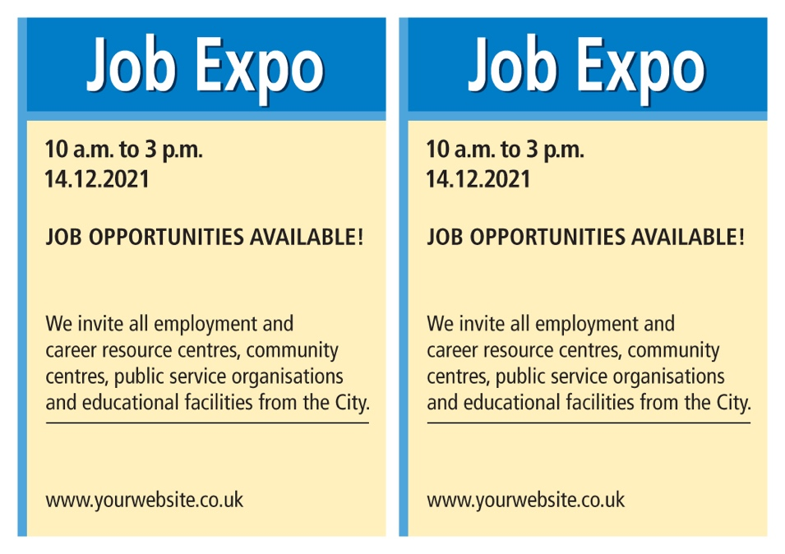

Here are some tips to help you create your leaflet.
- Set the page to landscape and make the margins narrow to make room for two leaflets on one A4 page.
- The main heading should be large and clear, to grab the attention of your intended audience.
- Use subheadings to break up large chunks of text.
- Images should add meaning to the text, and you could consider including image captions.
- Use all the available space, but don't be afraid of empty white space.
- Limit the number of fonts, font sizes and font colours; too many can be confusing.
Remember to save your work regularly.

Use the grid below to complete stage 1 of the design cycle: understand the task (ask yourself questions about the purpose of your document and its intended audience).

Purpose | What does the leaflet need to do? What information does it need to give to the person reading it? What should the person reading it do?
Audience | Who is the leaflet for? What will the intended audience find attractive and enticing?
Then move on to stage 2 of the design cycle: develop your ideas and plan a solution.
And, when you have planned your leaflet, move on to stage 3 of the design cycle: follow your plan to create your solution.

